# List of tables

|  |  |  |  |
| --- | --- | --- | --- |
| **SR**  **NO.** | **Table Name** | **Type of Table** | **Row Count** |
| 1 | DimAccount | Dimension | 24 |
| 2 | DimChannel | Dimension | 4 |
| 3 | DimCurrency | Dimension | 28 |
| 4 | DimCustomer_Company | Dimension | 386 |
| 5 | DimCustomer_Person | Dimension | 18,484 |
| 6 | DimDate | Dimension | 45,656 |
| 7 | DimEntity | Dimension | 421 |
| 8 | DimGeography | Dimension | 517 |
| 9 | DimProduct | Dimension | 2,517 |
| 10 | DimProductCost | Dimension | 27,060 |
| 11 | DimProductPrice | Dimension | 29,568 |
| 12 | DimPromotion | Dimension | 28 |
| 13 | DimSalesTerritory | Dimension | 265 |
| 14 | DimScenario | Dimension | 3 |
| 15 | DimStore | Dimension | 306 |

**Performance Statistics Of Talend DI**

|  |  |  |  |  |
| --- | --- | --- | --- | --- |
| **SR NO.** | **Table Populated** | **Number of**  **Inserts (Talend)** | **Number**  **of Rejects** | **Time taken (in Seconds)** |
| 1 | DimAccount | 24 | 0 | 0.687 sec |
| 2 | DimChannel | 4 | 0 | 0.639 sec |
| 3 | DimCurrency | 28 | 0 | 0.703 sec |
| 4 | DimCustomer_Company | 386 | 0 | 1.4 sec |
| 5 | DimCustomer_Person | 18,484 | 0 | 1.9 sec |
| 6 | DimDate | 45,656 | 0 | 3.1 sec |
| 7 | DimEntity | 306 | 0 | 1.5 sec |
| 8 | DimGeography | 517 | 0 | 1.4 sec |
| 9 | DimProduct | 2,517 | 0 | 2.0 sec |
| 10 | DimProductCost | 27060 | 0 | 610.1 sec |
| 11 | DimProductPrice | 29568 | 0 | 535.5 sec |
| 12 | DimPromotion | 28 | 0 | 1.4 sec |
| 13 | DimSalesTerritory | 265 | 0 | 1.5 sec |
| 14 | DimScenario | 3 | 0 | 0.5 sec |
| 15 | DimStore | 306 | 0 | 1.6 sec |
| 16 | FactExchangeRate | 2,192 | 0 | sec |
| 17 | FactSalesQuota | 3,839,378 | 4,68,557 | sec |
| 18 | FactStrategyPlan | 2,017,741 | 0 | sec |
| 19 | FactInventory | 9,270,723 | 210,650 | sec |
| 20 | FactOnlineSales | 3,820,218 | 9,76,238 | sec |
| 21 | FactSales | 883,292 | 41,819 | sec |
|  | **Master_Job** | - | - | **720.0 sec**  **~ 12 min** |

**Talend Screenshots**

1. DimAccount
2. DimChannel
3. DimCurrency
4. DimCustomer_Company
5. DimCustomer_Person
6. DimDate
7. DimEntity
8. DimGeography
9. DimProduct
10. DimProductCost
11. DimProductPrice
12. DimPromotion
13. DimSalesTerritory
14. DimScenario
15. DimStore
16. FactExchangeRate

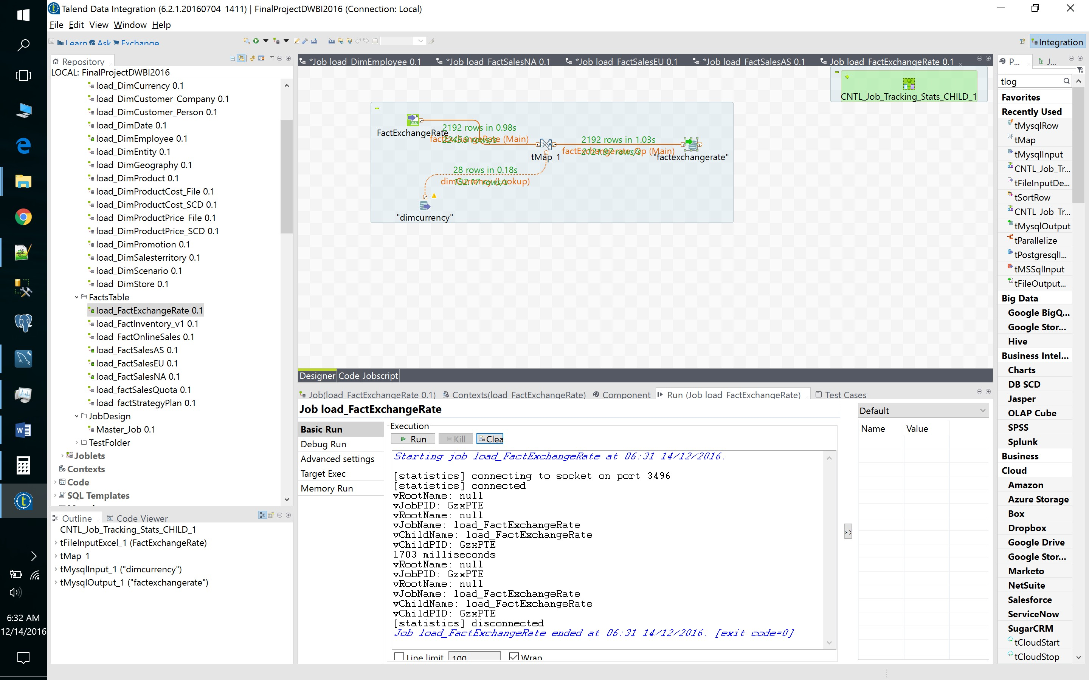

1. FactStrategyPlan

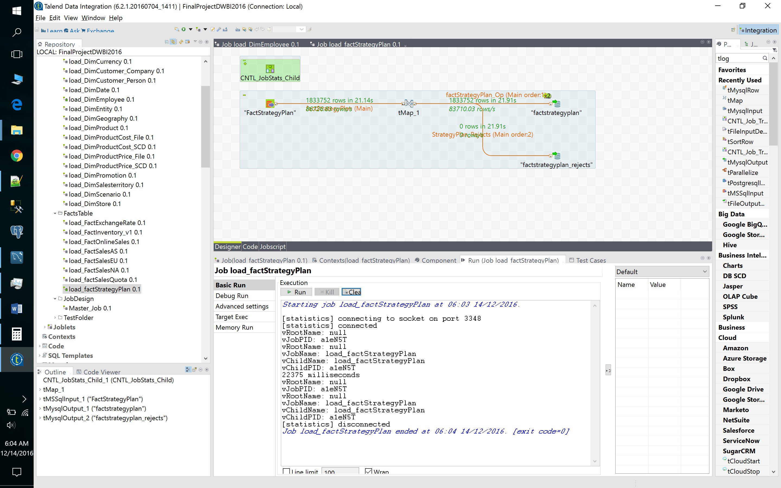

1. FactProductInventory

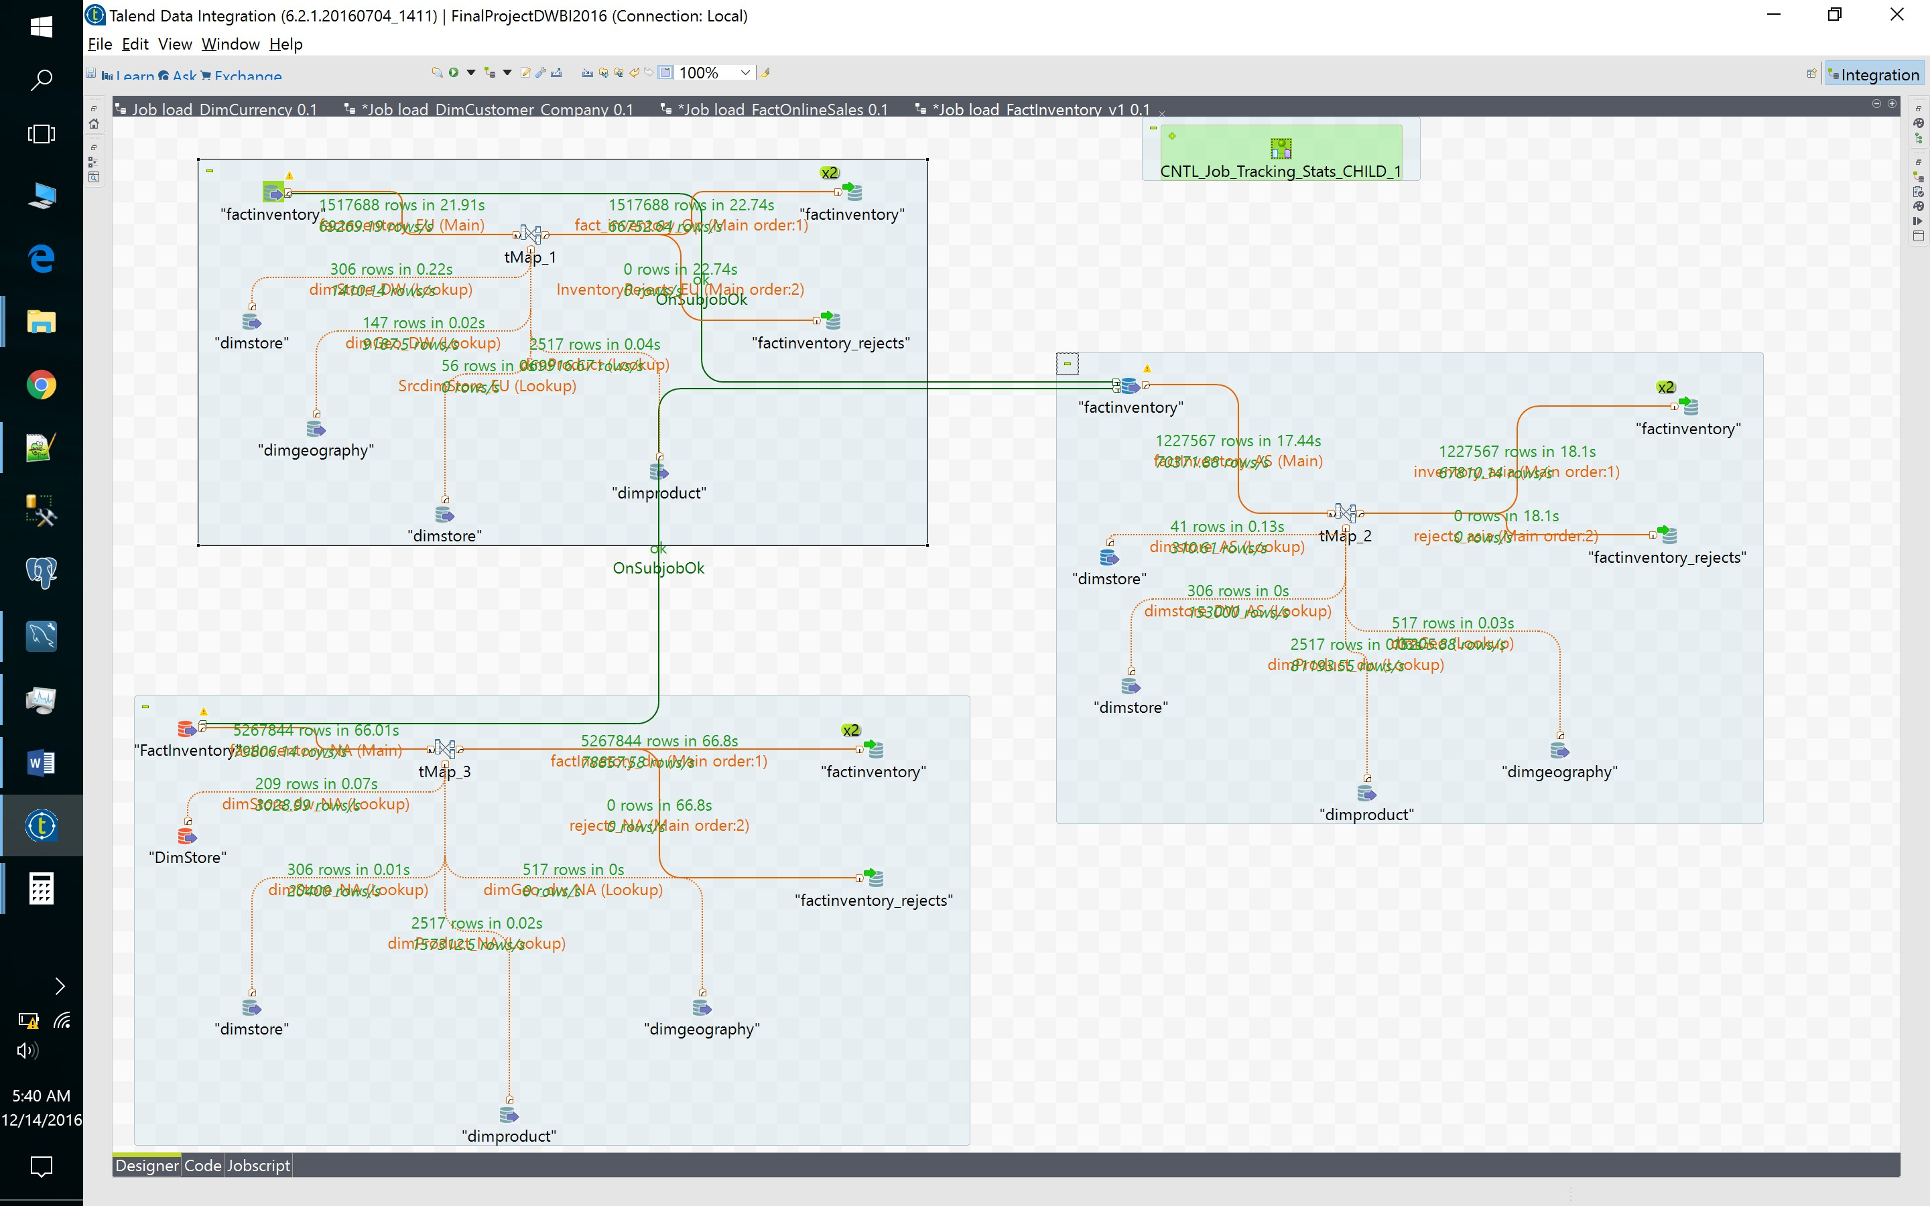

1. FactSalesQuota

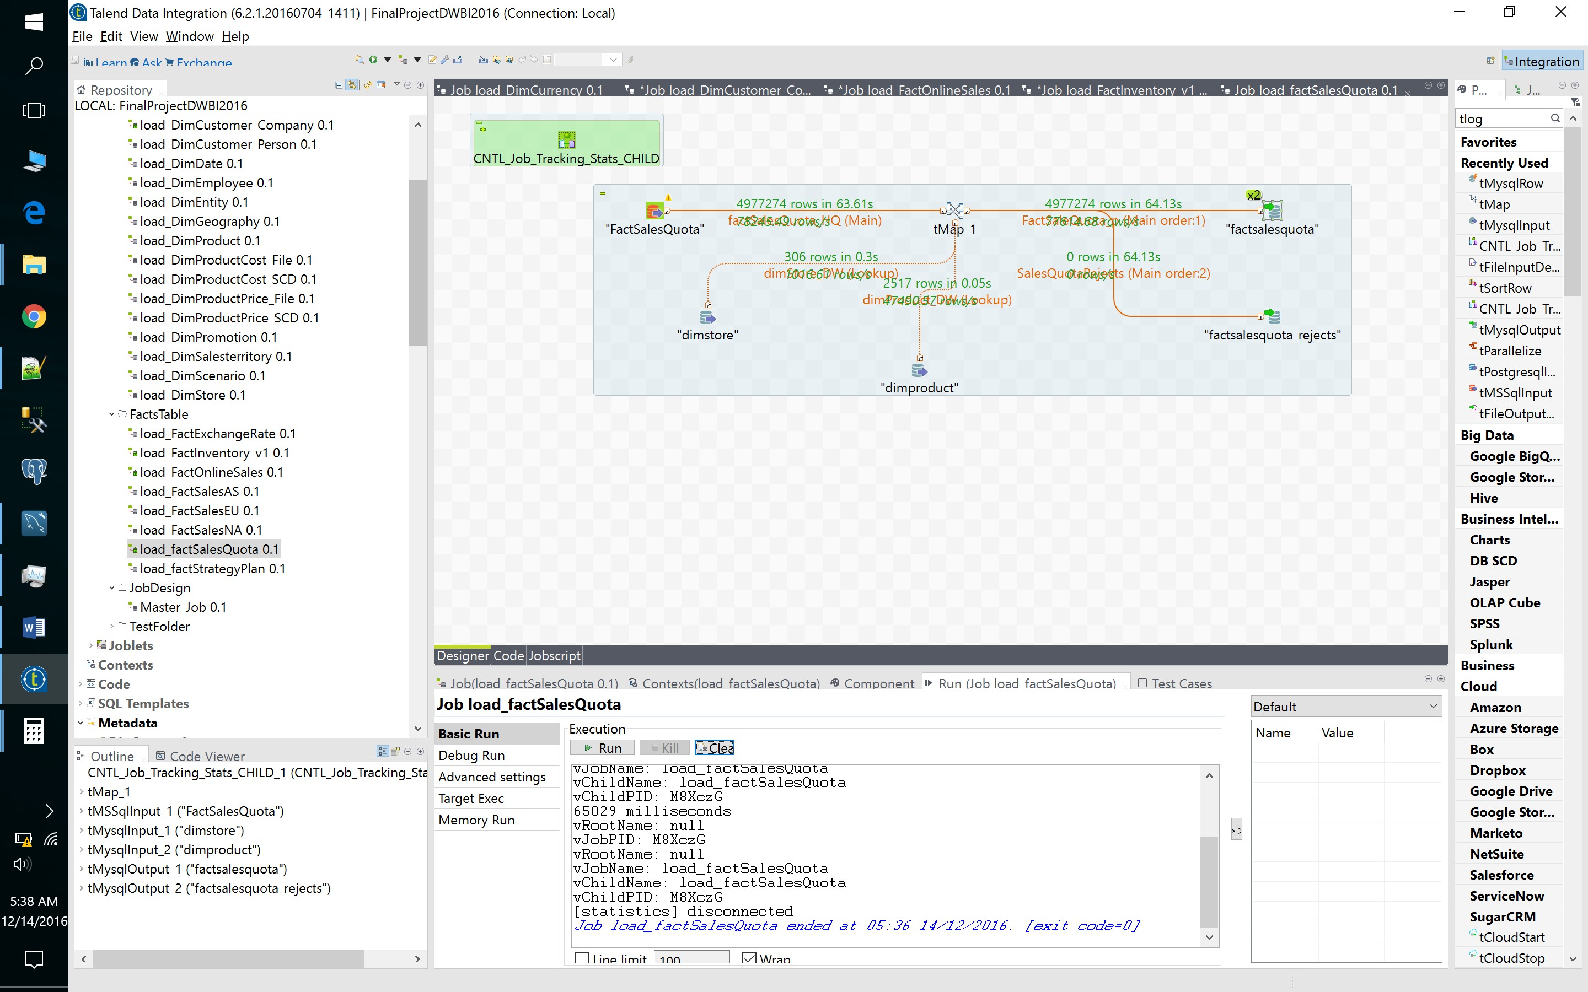

1. FactOnlineSales

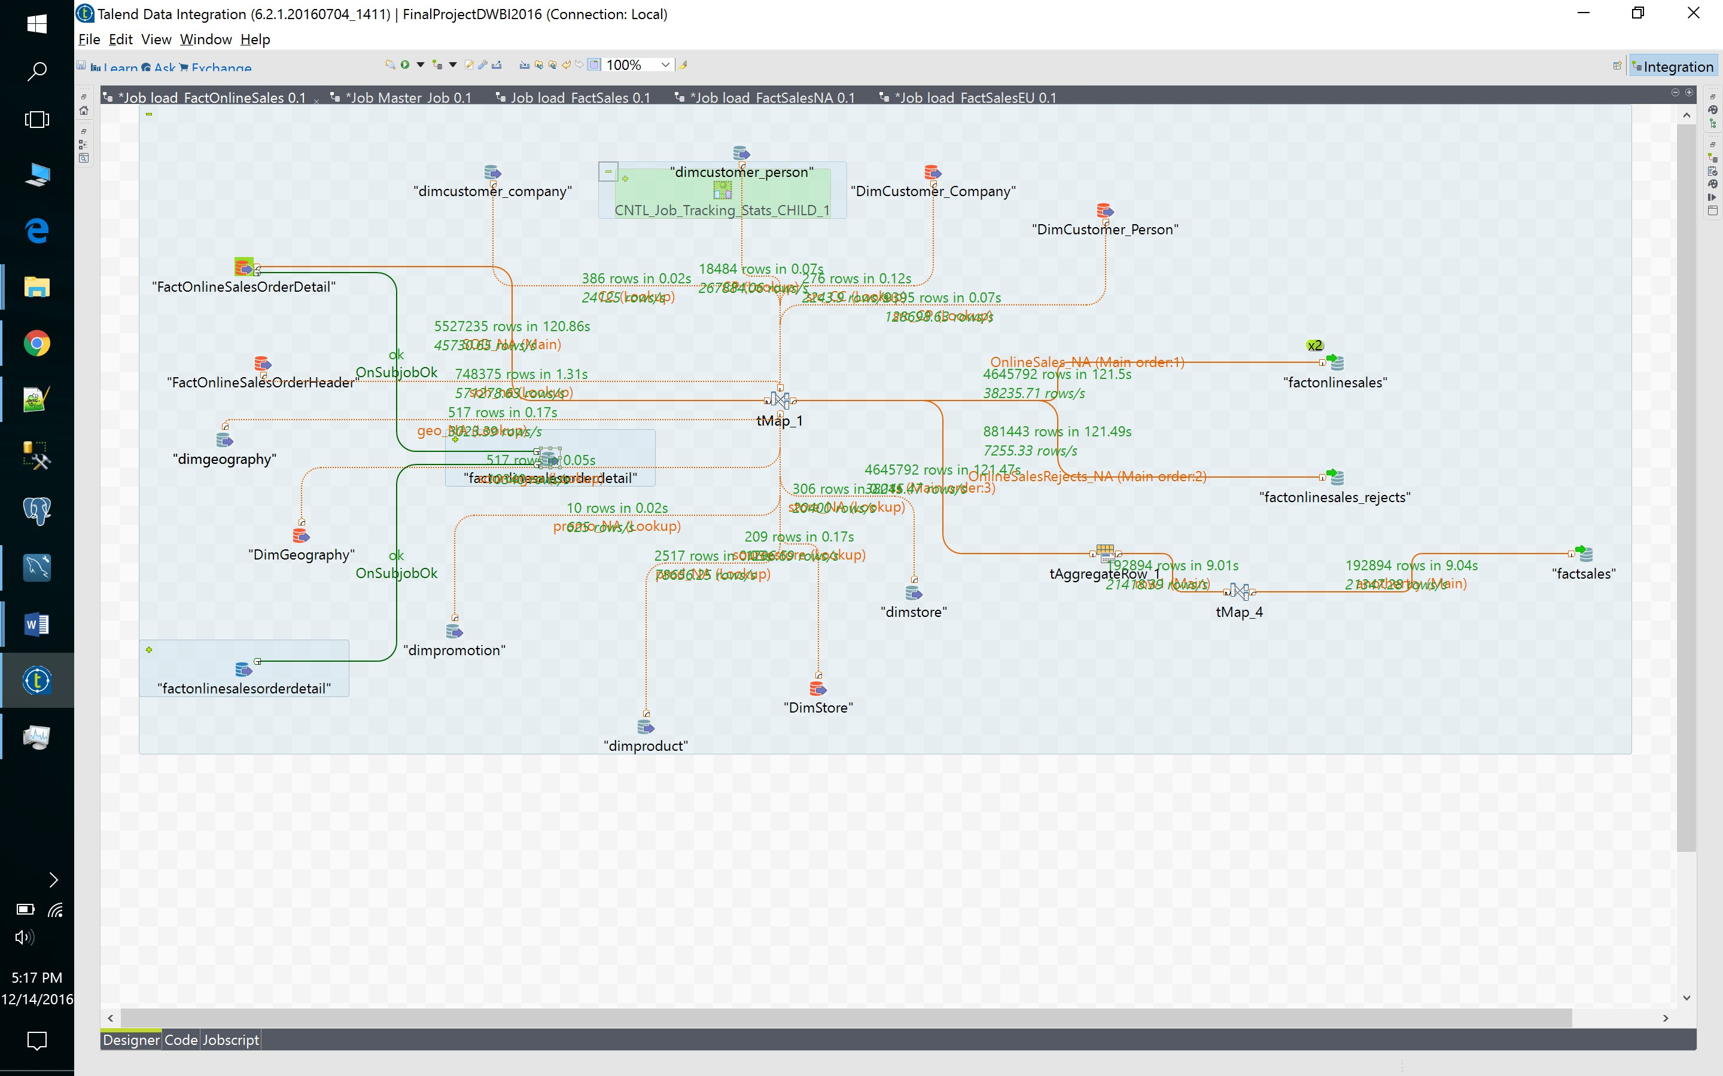

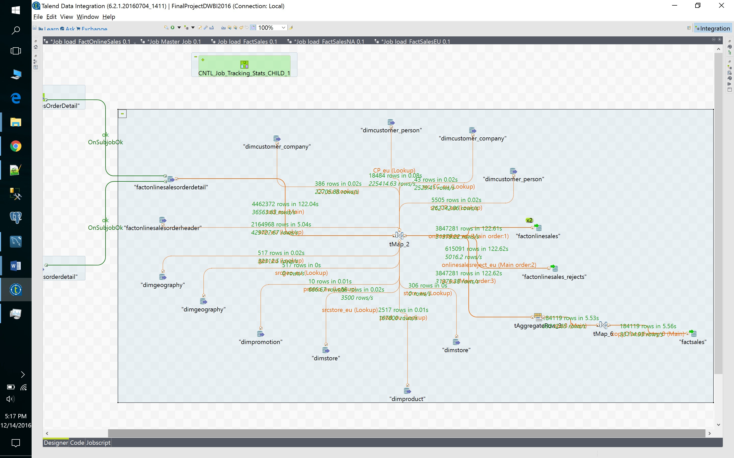

22. FactSales

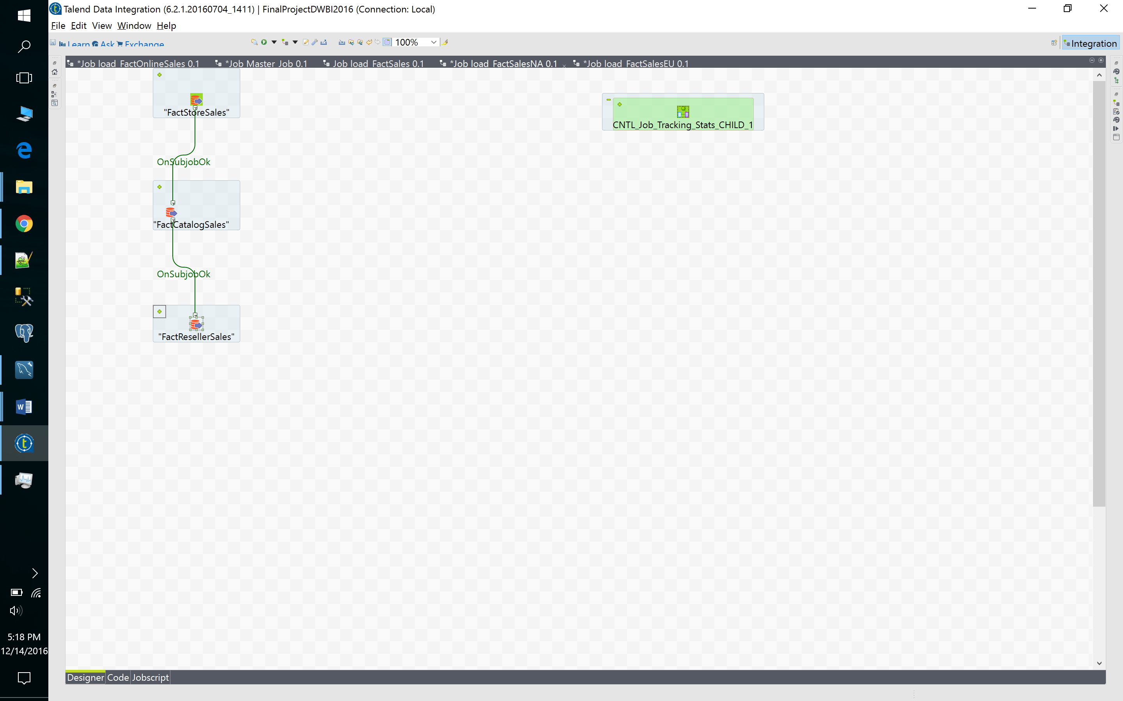

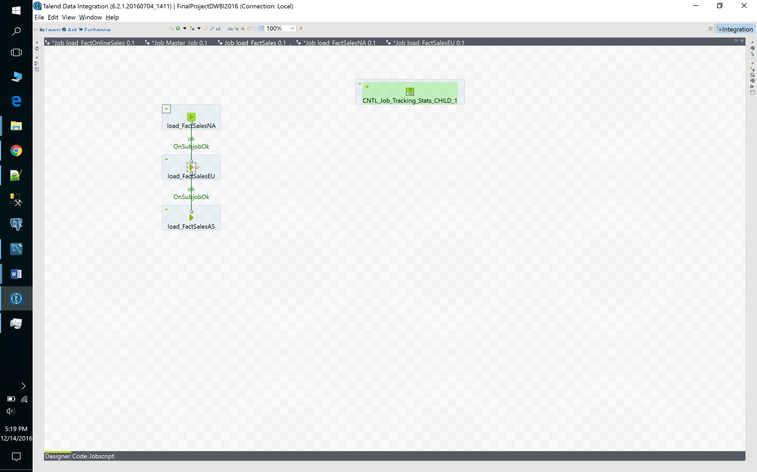

# Master Job Screenshot

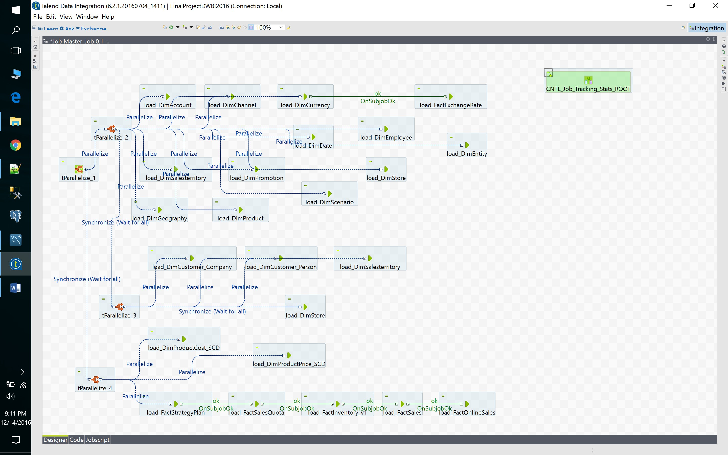

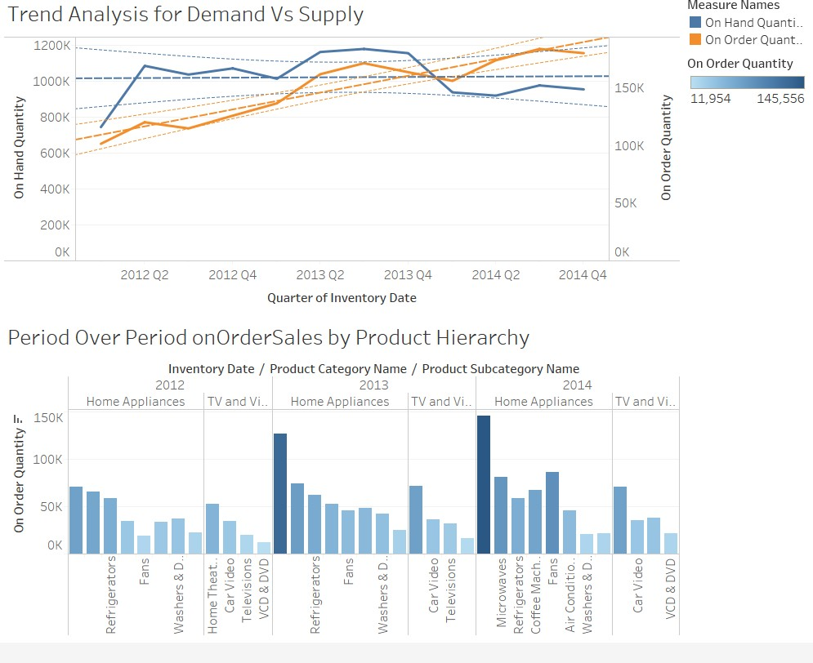**BI Dashboard Screenshots**

